Hei whakamahi i te tauira Tikanga Tuku Iho

I whakahouhia te tauira paetukutuku i runga ipurangi i te marama o Whiringā ā-nuku 2008, hei whakamāmā ake i te āhua ki te kiritaki me ngā momo kaupapa mahi. I whakahoutia anōtia te āhua me te ariā hoki, hei whakarato i ngā pūrākau kia whakaōrite te āhua, hei whakawātea mai kia whakauruhia ngā kōrero auaha mai i ngā ākonga.

Te whai wāhi i tō tauira

Ka rēhita ana koe ki te kaupapa Tikanga Tuku Iho, ka riro mai i a koe he īmēramai i te tīma o Tikanga Tuku Iho hei pōwhiri i ā koe. Kei roto hoki tō kupuhuna, ingoa rorohiko me te URL mō te whārangi whakauru.

Haere ki te whakauru URL, ā, whakauruhia tō ingoa rorohiko, me tō kupuhuna. Ka tkawea koe ki tō tauira pūrākau whaioro. Kei kōra:
- te ingoa o tō kura
- te taitara o tō pūrākau
- ētahi whārangi kua whakatūria kēhia: Ā mātou tīma, Te tukanga rapunga, Ngā putanga ako, Ngā whakapuakanga me ngā manakohanga

Ka taea e koe te ētita i ēnei whārangi hei whakamōhio mai i te tukanga mō to pūrākau o Tikanga Tuku Iho. Ka taea anō koe te hangaia (te whakakore rānei) i ngā whārangi tāpiri e hāngai ana ki tō take pūrākau.

Mā tēnei tauira o Tikanga Tuku Iho ka taea e koe ngā momo kaupapa mahi hei hanga i ētahi haki pae motuhake, te hanga me te wetewete i ngā whārangi, ngā ataata i mau ai, ngā rīpene ataata me ngā kōnae tā youtube (eg Powerpoints, rīpanga, PDFs) me te hono ki ngā pae ā-waho.

Ka taea anō e koe te whakatakoto i āu whārangi i roto i tētahi momo āhuatanga motuhake, te whakarerekē i te kano me te rahi o tō tuhinga, te rahi me te tīaroaro o ngā ataata, te tāpiritanga i ngā bullet points me ngā ripanga.

This screen shot shows the screen you will see after clicking the ‘edit’ button on your template homepage:
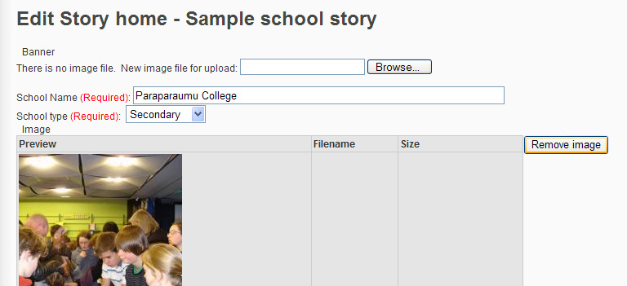
Tuku ake i tētahi ataata hei haki pae mōu.
Tohu: He pai ake mēna he 800 te whānui, he 600 te teitei o ngā pixels. Hei whakarite i ngā ine mō aua ataata, pāwhiri i te taha maui, ka kōwhiri i ngā momo rawa. Mēnā kāre e taea tēnei ataata ki tō rahi, ka taea e koe te whakarereketia i tō rorohiko. Eg. Hei whakamahia i tētahi taputapu ētita pikitia.

Kei tēnei whārangi kainga ētahi wāhi hei whakarewa i te ataata matua e kīia ai ko te ‘ataata tuatangata’. Tuku ake tēnei mai i kōnei.

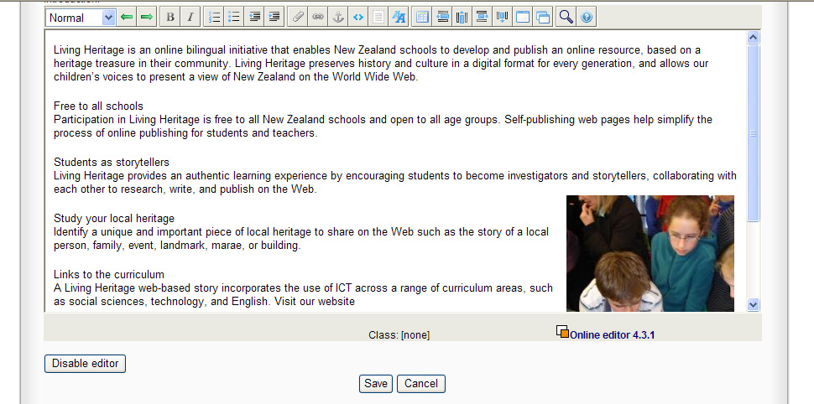
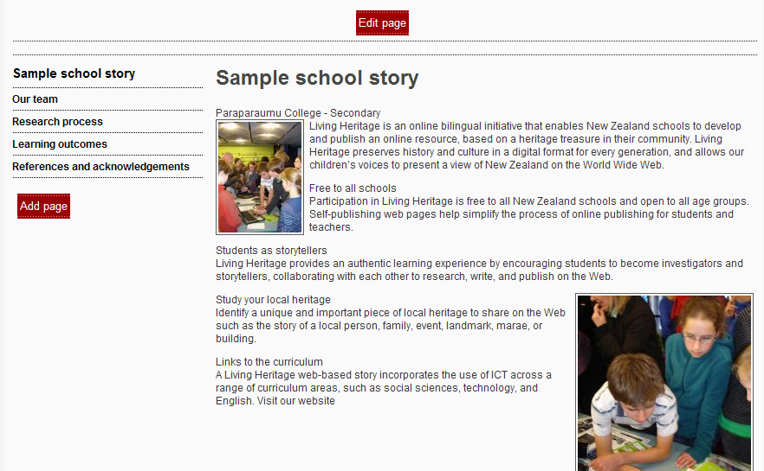
Whakatikahia te whārangi mohoa

Kei kōnei te taitara ō tō pūrākau i te wā e whakauru atu.

Kei puritia te ingoa ō tō kura I konei, ka taea koe te whakauru atu.

Ngā whārangi whakarite

Tāpirihia ētahi whārangi hou i te taha mauī o te paerārangi

Ka taea e koe te hanga i tō ake tuhinga/ataata mō tēnei whārangi

These screenshots show the editing box that will appear after clicking the ‘edit’ button in the above screenshot:

Wetekina / mahia ai

Whakauruhia tētahi hononga paetukutuku

Kōwhiria i te whakaritenga māori, i ngā tumomo āhua whakaūpoko

Mēnā e kape ana koe i ngā tuhinga mai i a Word, tērā pea me whakauru koa mai ki roto ki te tuataka tuhi i te tuatahi.

Pupuritia me whakakorehia rānei āu whakatika.

Te Whakauru i tētahi hononga
- Patohia i te tohu hononga
- I te wāhanga ‘tuhinga’, whakauruhia ngā tuhinga e hiahia ana koe hei whakaatu i runga i tō whārangi, i hononga-itua ai.
- Tohu: Ka taea e koe te tipako i ngā tuhinga ki tō pouaka etita, ā, ka taea rānei te patopato i te tohu hononga. Ka taea tēnei te whakarato aunoa i aua tuhinga ki roto ki te wāhanga ‘tuhinga’.
- Ki te wāhanga ‘URL’, whakatakotohia āu URL
- Ka taea rānei e koe te kōwhiri mēnā e hiahia ana koe te whakapuaretia i tētahi matawai hou. He āhuatanga pai tēnei i te mea kāre hoki te kaitangotango i warea ai ki tō pae.
I mau ai i tētahi ataata, i te kōnae rānei

I mau ai i tētahi rīpene ataata tā youtube

Whakauruhia i tētahi ripanga

Hei whakakanohia i tō tuhinga, pātoto katau mā runga te tuhinga, ā, ka kōwhiria i ngā momo rawa. I raro iho nei o ‘momo’, kōwhiria ngā kano.

Te Whakapūmauhia i tētahi ataata
- Patohia te tohu puripuka
- Patohia “Tuku ake ai te mea hou”
- Patopatohia te ingoa o tō ataata
- Patohia ‘Honi’, ā, kōwhiria hoki i tētahi ataata mai i tō kōnae
- Kōwhiria te ‘OK’
- Ka taea e koe te kōwhiri i te rahi me te tūranga o tō ataata i runga i te whārangi
- Whakamahia te rārangi tono whakararo hei kōwhiri i tētahi ataata pakupaku, tau waenga, i te rahi hoki.
- Whakamahia te rārangi tono whakararo tuarua hei kōwhiri, hei tīaroaro i waenganui, te taha matau, i te taha māui rānei.
- Pupuritia aua whārangi
- Tohu: I te wā ka oti i a koe te whakapūmau i te ataata, mēnā ka hiahia koe ki te whakarerekē, ki te whakauru rānei ki roto ki te tirohanga whārangi etita, kōwhiria te ataata; patohia i te taha matau, ā, kōwhiria ngā momo rawa. Kei kōnei ka taea e koe te whakarerekē.

Te Whakapūmauhia i tētahi kōnae
- Patothia te tohu puripuka
- Patohia “Tuku ake ai te mea hou”
- Patopatohia te ingoa o tō kōnae
- Patohia ‘Honi’, ā, kōwhiria hoki tētahi ataata mai i tō rorohiko
- Kōwhiria te ‘OK’
- Ka taea e koe te kōwhiri i te rahi me te tūranga o tō ataata i runga i te whārangi
- Whakamahia te rārangi tono whakararo hei kōwhiri i tētahi ataata pakupaku, tau waenga,me te rahi hoki.
- Whakamahia te rārangi tono whakararo tuarua hei kōwhiri, hei tīaroaro i waenganui, te taha matau, i te taha māui rānei.
- Pupuritia aua whārangi
- Tohu: I te wā ka oti i a koe te whakapūmau i te ataata, mēnā ka hiahia koe ki te whakarerekē, ki te whakauru rānei ki roto ki te tirohanga whārangi etita, kōwhiria te ataata; patohia i te taha matau, ā, kōwhiria ngā momo rawa. Kei kōnei ka taea e koe te whakarerekē.

Te Whakapūmau i tētahi rīpene ataata tā youtube
- Hei kōkiritanga, haere ki te wāhi youtube, ki te rapu i tō ataata
- Tangohia i tētahi wāhanga o te URL, ā, whakakapehia
- Tirohia tēnei tauira. Ka taea e koe te rapu i te wāhanga whero Eg: http://www.youtube.com/v/(Insert MovieID)
- Pātohia te tohu youtube
- Tuhia, whakaingoatia hoki te tuhinga e hiahia ana koe hei whakaatu i ngā wāhanga tuhi
- Kei te wāhanga URL, whakakorea te Eg: engari, ko te tikanga, pupuritia te toenga o taua URL puta aunoa. Whakauruhia te wāhanga o taua ID Pikitia i whakakape e koe.
- Me whakaritea ngā ine ki nga ritenga aunoa.
- Kōwhiria te OK

Te whakamahi tuhinga, kano rānei
- Tohu: kāre e taea te whakamahi i ētahi momo kano i roto i te rārangi kotahi / wāhanga o te tuhinga. Ko te tikanga, whakawāteahia tētahi rārangi whati i mua ka taea koe te tāpiri atu i ētahi momo kano.
- Whakatakotohia tō kaitiri i roto i rārangi tuhinga (kaua e tīpakohia)
- Patohia te taha matau, ā, ka kōwhiri i te ‘momo rawa’
- Mai i te rārangi tono whakararo, kōwhiria te kano e hiahia ana koe
- Hei whakamārama: kei reira anō ngā momo pū rahi hei kōwhiri mōu. Eg, 1, 2, 3 (ko te 1 te mea pakupaku noa).

Whakauruhia tētahi rīpanga
- Patohia te tohu rīpanga
    - Whakaritea te nui o ngā haupae me te tiwae e hiahia ana koe
    - Kōwhiria te OK

